PCB

Power distributor: is important because it delivers electricity safely and efficiently from the buck regulator to the sensors, microcontrollers, LCD, and motors. It ensures that energy reaches the correct voltage with minimal losses. It acts as an organized hub, making it easy to troubleshoot faulty components and preventing dangerous wire overheating by managing current flow properly.

The 8 components that will be attached to the 8 terminals:
- Servo motor lifting
- Solenoid lifting
- IR sensor lifting
- Bluetooth module shooting
- Ultrasonic sorting
- Ir sorting
- Servo sorting
- LCD sorting
- ENCODER

PCB schematic
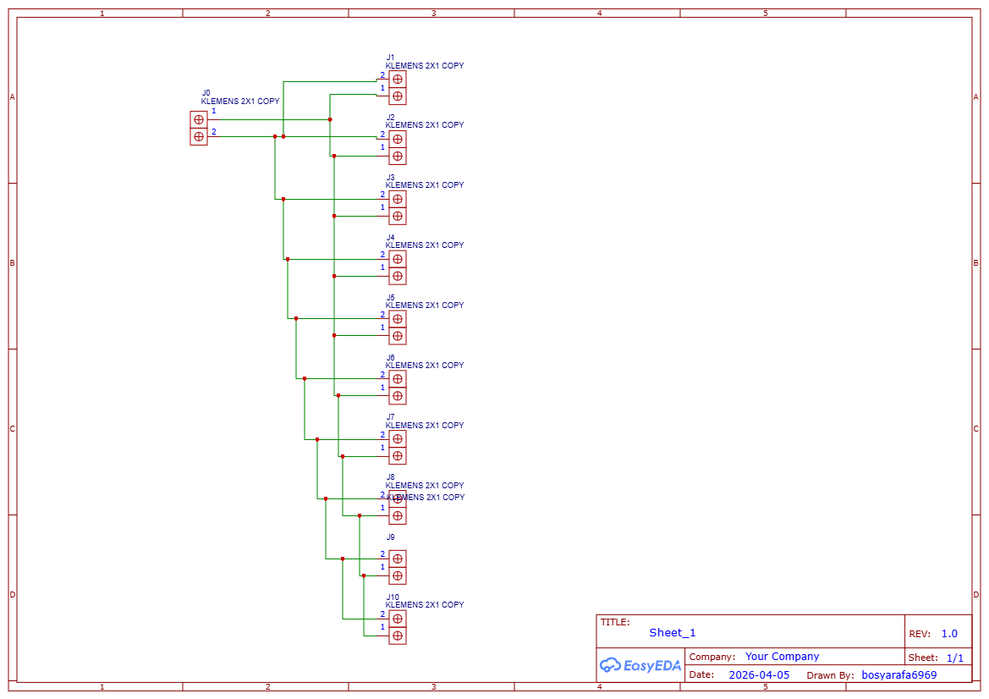

PCB layout
